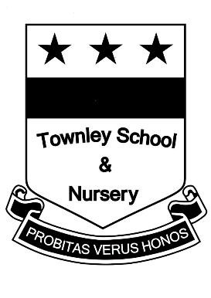
Townley School is committed to safeguarding and promoting the welfare of children and young people and expects all staff to share this commitment

Job Title: Teaching Assistant – Level 1A

Grade: Level 1A

Hours: 16 ¼ per week

Job Purpose:

Support the classroom teacher to facilitate the active participation of children in the academic and social activities of the school.

Principal Accountabilities:

1. Support for children

- Under the direction of the teacher, carry out pre-determined tasks to support pupil learning.
- Establish and maintain supportive relationships with individual pupils or small groups to ensure they understand and can achieve the tasks.
- Provide learning support as required for children with special needs, or where English is not their first language.
- Help with the care and support for pupils, including attending to their emotional and/or physical care needs.
- Support inclusion in the classroom, ensuring all pupils feel involved with tasks and activities.

2. Support for the curriculum

- Under the direction of the teacher, support the school curriculum, including literacy and numeracy activities.
- Support the use of ICT in the curriculum

3. Support for the teacher

- Provide information to help the class teacher plan appropriate work programmes.
- Help to prepare the learning environment for use.
- Undertake support activities for the teacher as required, e.g. photocopying, prearation of materials, mounting displays.
- Contribute to the management of pupil behaviour and take control of minor situations to allow the teacher to continue the lesson.

- Support for the school

  - Develop and maintain effective working relationships with other staff.
  - Contribute to the maintenance of a safe and healthy environment.
  - Attend and actively participate in staff meetings.
  - Provide support for school events, e.g. school plays, events.
  - Provide First Aid across the whole school.
  - Provide classroom cover as required across the school.

