Townley School & Nursery
Crown Road, Christchurch, Wisbech, Cambs PE14 9NA
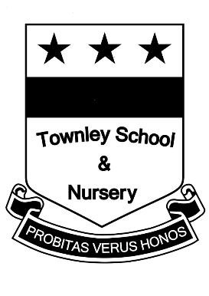
office@townley.cambs.sch.uk Tel: 01354 638229
www.townley.cambs.sch..uk

Headteacher: Mrs Maria-Anne Higgins

Person Specification – Teaching Assistant

Criteria | Weighting
- Proven experience of working with children | 10
- Level 2 qualifications related to TA work | 2
- Experience of working as a TA | 5
- GCSE/O Level grade C or above in English and Maths | 5
- A clear DBS check which confirms suitability to work with children. This will be carried out after interview | N/A until after interview
- An understanding of the national curriculum/EYFS | 3
- An understanding of child development and of children's needs | 3
- Ability to adapt planning as necessary | 3
- Ability to follow a teachers direction and present quality feedback about the impact of work carried out | 3
- Have an understanding of child protection, safeguarding, diversity and equality. | 5
- Ability to manage self and work calmly under pressure | 2
- Ability to communicate effectively with children and adults with a good command of the spoken and written English language | 3
- Demonstrate professionalism in approach to managing all issues | 2
- Demonstrate flexibility within a work place and show an understanding of the need for flexibility within the role | 3
- Ability to manage children’s challenging behaviours | 1
- Ability to use own initiative | 1
- Ability to work as part of a team | 1
- Be committed to the school ethos and aims | 1
- Be committed to and take an active part in school development training and priorities | 1
- Good ICT skills. | 1
- A positive attitude to work | 1
- A willingness to be involved in whole school development. | 1
- Excellent organisational skills | 1
- An understanding of the need for confidentiality | 1
- First Aid Qualification | 1
- Willingness to meet medical needs of child | 10
Townley School is committed to safeguarding and promoting the welfare of children and expects all staff, visitors and volunteers to share this commitment”

